**Ahsanullah University of Science & Technology Department of Computer Science & Engineering**

**Semester fall 2020**

**CSE 3216**

**Microcontroller Based System Design Lab**

**Final Project Report**

**Project Name: Water Overflow Detection & Control**

**Submitted To**

Afsana Ahmed Munia Mr. Farzad Ahmed

Assistant Professor Lecturer

Department of CSE, AUST Department of CSE, AUST

**Submitted By**

|  |  |
| --- | --- |
| **Nujhat Tabassum** | **180104024** |
| **Rachita Dewanjee** | **180104029** |
| **Mubina Ashrafi** | **180104030** |
| **Sadia Nawsin** | **180104049** |

**Objectives:**

One of the major problems faced by most of the countries is the issue of water scarcity in the world. The scarcity is mainly due to the wastage of the water. There is a need to control the water wastage to save the environment and water resources. Water level monitoring system is one of the techniques to address the control of water wastage. All the householders are storing the water in overhead tanks by using the motor pumps. When the water is stored in the tank, no one can identify the level of water and also, no one can know when the water tank will be filled. So, there is an overflow of water in the tank, which results wastage of energy and water. To resolve this type of problems by using implementation water level indicator and controller using ultrasonic sensor and to decrease water scarcity we can collect rain water and check the quality of water.

**Social Values:**

1. An early detection will help reduce the amount of water wastage.
2. Sometimes, even if the water overflows from the water tank, the water pump will continue to pump water, so it help prevent water overflow during pumping.
3. Helps to prevent wastage of energy and water.
4. Helps to determine the PH of the water
5. PH sensor measure PH value which can be used as one reference point for reflecting the cleanliness of the water
6. Help monitor the water quality at home supply, in Agricultural Farm and fish farming.
7. Collect rain water can Decrease the scarcity of water.
8. Collecting and using rainwater to replace municipal water use reduces your water bill.
9. The main purpose of a water level indicator is to gauge and manage water levels in a water tank.

# Required Components:

* Arduino Mega
* 16*2 LCD
* Ultasonic Sensor
* LED
* Sounder
* POT-HG
* Servo
* Rain Sensor
* Connecting Wire
* Resistor
* Motor

**Member Contribution:**

# Working Procedure:

# The Ultrasonic sensor module will transmit for receiving ECHO.

# The Arduino will read the time between activation and receiving from ECHO which will help calculate the water level

# This sensor module will read the distance between the sensor module and the water surface and it will display the distance on the LCD screen with the message.

# When the empty water level will reach at predetermined distance, the Arduino will turn on the motor .Otherwise the Arduino will turns off on the motor.

# The LCD display will show the output and the buzzer will also beep for sometimes.

# If it is raining and the water level is below the predetermined distance the motor will turn on and collect rain water.Otherwise it will turn off the motor.

# The PH and TDS sensor will build by to pot-hg. By varying pot, the pot sensor will take the PH and TDS value and then display this value on the LCD.

# Estimated Budget:

|  |  |  |
| --- | --- | --- |
| **Equipment** | **Quantity** | **Budget(TK)** |
| Arduino MEGA | 1 | 1100 |
| 16x2 LCD | 1 | 200 |
| Ultrasonic Sensor | 1 | 98 |
| Sounder | 1 | 800 |
| Servo | 1 | 335 |
| LED | 4 | 800 |
| Resistor | 1 | 70 |
| POT-HG | 2 | 100 |
| Rain Sensor | 1 | 180 |
| Connecting wire | As Required | 280 |
| Motor | 1 | 40 |
| **Total=4003tk** | | |

**Code:**

#include <LiquidCrystal.h>

#include<Servo.h>

#define trigger 10

#define echo 11

#define motor 12

#define buzzer 13

//#define actuator 9

#define rain 8

int ph = A0;

int ph_value=0;

Servo myservo;

const int rs = 7, en = 6, d4 = 5, d5 = 4, d6 = 3, d7 = 2;

LiquidCrystal lcd(rs, en, d4, d5, d6, d7);

float time=0,distance=0;

int temp=0;

void setup()

{

lcd.begin(16,2);

pinMode(rain,INPUT);

pinMode(trigger,OUTPUT);

pinMode(echo,INPUT);

pinMode(motor, OUTPUT);

pinMode(buzzer, OUTPUT);

//pinMode(actuator, OUTPUT);

pinMode(22,OUTPUT) ;

pinMode(23,OUTPUT) ;

pinMode(24,OUTPUT) ;

myservo.attach(9);

lcd.print(" Water Level ");

lcd.setCursor(0,1);

lcd.print(" Indicator ");

delay(500);

Serial.begin(9600);

}

void loop()

{

digitalWrite (motor,LOW);

//digitalWrite (actuator,LOW);

myservo.write(0);

int rain_val=digitalRead(rain);

ph_value=analogRead(ph);

ph_value=((ph_value*0.0009765625)*100);

lcd.clear();

digitalWrite(trigger,LOW);

delayMicroseconds(2);

digitalWrite(trigger,HIGH);

delayMicroseconds(10);

digitalWrite(trigger,LOW);

delayMicroseconds(2);

time=pulseIn(echo,HIGH);

distance=time*0.034/2;

lcd.clear();

lcd.print("Water Space In this ");

lcd.setCursor(0,1);

lcd.print("Tank is: ");

lcd.print(distance);

lcd.print("Cm");

delay(2000);

if(distance<12 && temp==0)

{

digitalWrite(motor, LOW);

digitalWrite(buzzer, HIGH);

//delay(3000);

lcd.clear();

lcd.print("Water Tank Full ");

lcd.setCursor(0,1);

lcd.print("Motor Turned OFF");

delay(2000);

digitalWrite(buzzer, LOW);

delay(3000);

temp=1;

delay(1000);

}

else if(distance<12 && temp==1)

{

digitalWrite(motor, LOW);

lcd.clear();

lcd.print("Water Tank Full ");

lcd.setCursor(0,1);

lcd.print("Motor Turned OFF");

delay(500);

}

else if(distance>=12 && distance <=30)

{

digitalWrite(motor,HIGH);

}

else if(distance>30)

{

lcd.clear();

lcd.print("LOW Water Level");

lcd.setCursor(0,1);

lcd.print("Motor Turned ON");

delay(500);

digitalWrite(motor, HIGH);

delay(500);

temp=0;

}

if(rain_val==1 && distance>12)

{

lcd.clear();

lcd.print("Storing Rain Water " );

delay(100);

//lcd.clear();

if(distance>12)

{

//digitalWrite(actuator,HIGH);

myservo.write(69);

delay(500);

}

//digitalWrite(actuator,LOW);

myservo.write(0);

delay(100);

}

else if((rain_val==1||rain_val==0) && distance<=12)

{

digitalWrite(buzzer,HIGH);

//digitalWrite(actuator,LOW);

myservo.write(0);

delay(500);

digitalWrite(buzzer,LOW);

digitalWrite(motor,LOW);

}

if(ph_value>0 && ph_value<8)

{

// lcd.clear();

//lcd.setCursor(0,1);

lcd.clear();

lcd.print("PH_Value= ");

lcd.print(ph_value);

lcd.setCursor(0,1);

lcd.print("PH_Acidic");

delay(1000);

digitalWrite(22,HIGH);

delay(1000);

digitalWrite(22,LOW);

}

else if(ph_value<14&& ph_value>7)

{

//lcd.clear();

//lcd.setCursor(0,1);

lcd.clear();

lcd.print("PH_Value= ");

lcd.print(ph_value);

lcd.setCursor(0,1);

lcd.print("PH_Basic");

delay(1000);

digitalWrite(23,HIGH);

delay(1000);

digitalWrite(23,LOW);

}

else if(ph_value>14){

//lcd.clear();

//lcd.setCursor(0,1);

lcd.clear();

lcd.print("PH_Value= ");

lcd.print(ph_value);

lcd.setCursor(0,1);

lcd.print("PH_Abnormal");

delay(1000);

digitalWrite(24,HIGH);

delay(1000);

digitalWrite(24,LOW);

}

else

{

lcd.clear();

lcd.print("Problem in PH Sensor");

//digitalWrite(actuator,HIGH);

myservo.write(69);

delay(500);

//digitalWrite(22,HIGH);

//digitalWrite(23,LOW);

}

}

**Design:**

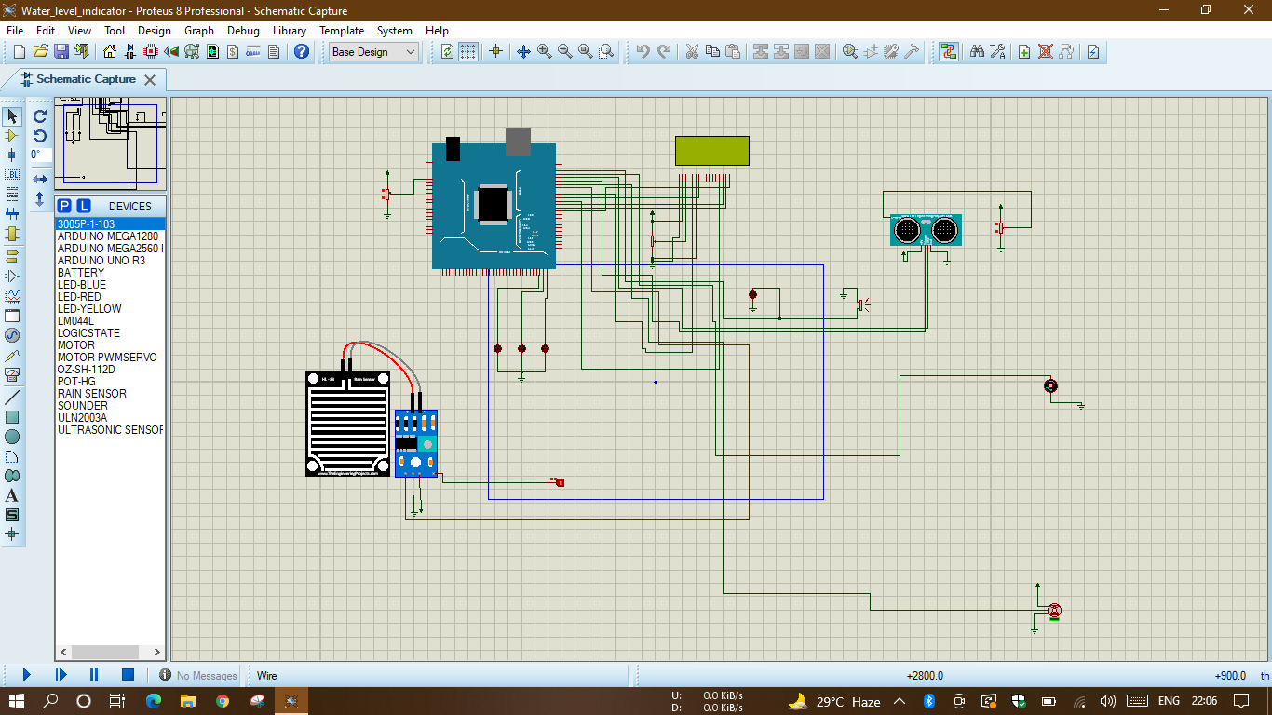

**Difficulties:**

* Different members are using different version of proteus that cause a problem when merging the project.
* As we have to do software implementation ,so we have to check the the output by using led light.We don’t get the chance to check the output by giving hardware setup.
* Because of software implementation we have to add necessary libraries.

**Future Plans:**

* In Future we want to detect the leakage of tank and Stop water from leakaging.
* We also want to find out temperature of the water and will give supply of home office it when it is in suitable temperature.

**Conclusion:**

Automation of the various components around us has been widely increased to reduce human intervention and save time. The water tank overflows as the height of water in the tank cannot be randomly guessed. This leads to extra energy consumption, which is a high concern in the present. People also need to wait and stop doing their other activities until the tank is full. Hence, here is an idea which senses and indicates the water level so that the pump can be switched off on appropriate time and save water, electricity and time as well. Therefore “Automatic Water Level Indicator and Controller Using Arduino ”project can definitely be useful on a large scale basis due to minimum requirement of man power and also the installation process being easier making more compatible for everyone to use. The pH indicator will show the pH value in the water, which will help people stay away from health or skin diseases. Using TDS sensor to find the drinking water is clean or not.And by collecting rain water we can decrease the water scarcity problem on lagre scale.